Mid-Point Check-in: Team Sandman (Polymer Property Prediction)
Project Title: Physics-guided, evidence based polymer property prediction from repeat-unit SMILES
Team Name: Sandman (Vishwa Kumaresh)
Primary Domain: Artificial Intelligence and Data Science (Computer vision and real time video analytics)
This report reports a seven-property pipeline for glass-transition temperature (Tg), chain and bulk bandgaps (Egc, Egb), ionisation energy (Ei), electron affinity (Eea), refractive index (n), and dielectric constant (ε). The submitted notebook records a 0.907551 mean R² on the local held-out verification panel and 0.920 on the public leaderboard.

1. Proposed Strategy and Technical Novelty

Novelty : A polymer-aware answer to two different problems
We propose a property-aware pipeline that recognises that this dataset contains two very different prediction settings. Tg usually requires learning from polymer structure to a new measured property. The smaller electronic and optical targets often have the same polymer measured for a different property, so they can benefit from a carefully checked cross-property signal. Treating all seven targets as one pooled problem would miss this distinction and over-focus on Tg.
The pipeline therefore combines three ideas: (1) polymer-specific and molecular representations, (2) one learned prediction lane for every property, and (3) simple physical relations used only when they improve validation. This lets us use chemistry where it helps while keeping a learned model available for every target [1–3].

Methodology, Architecture and Reasoning
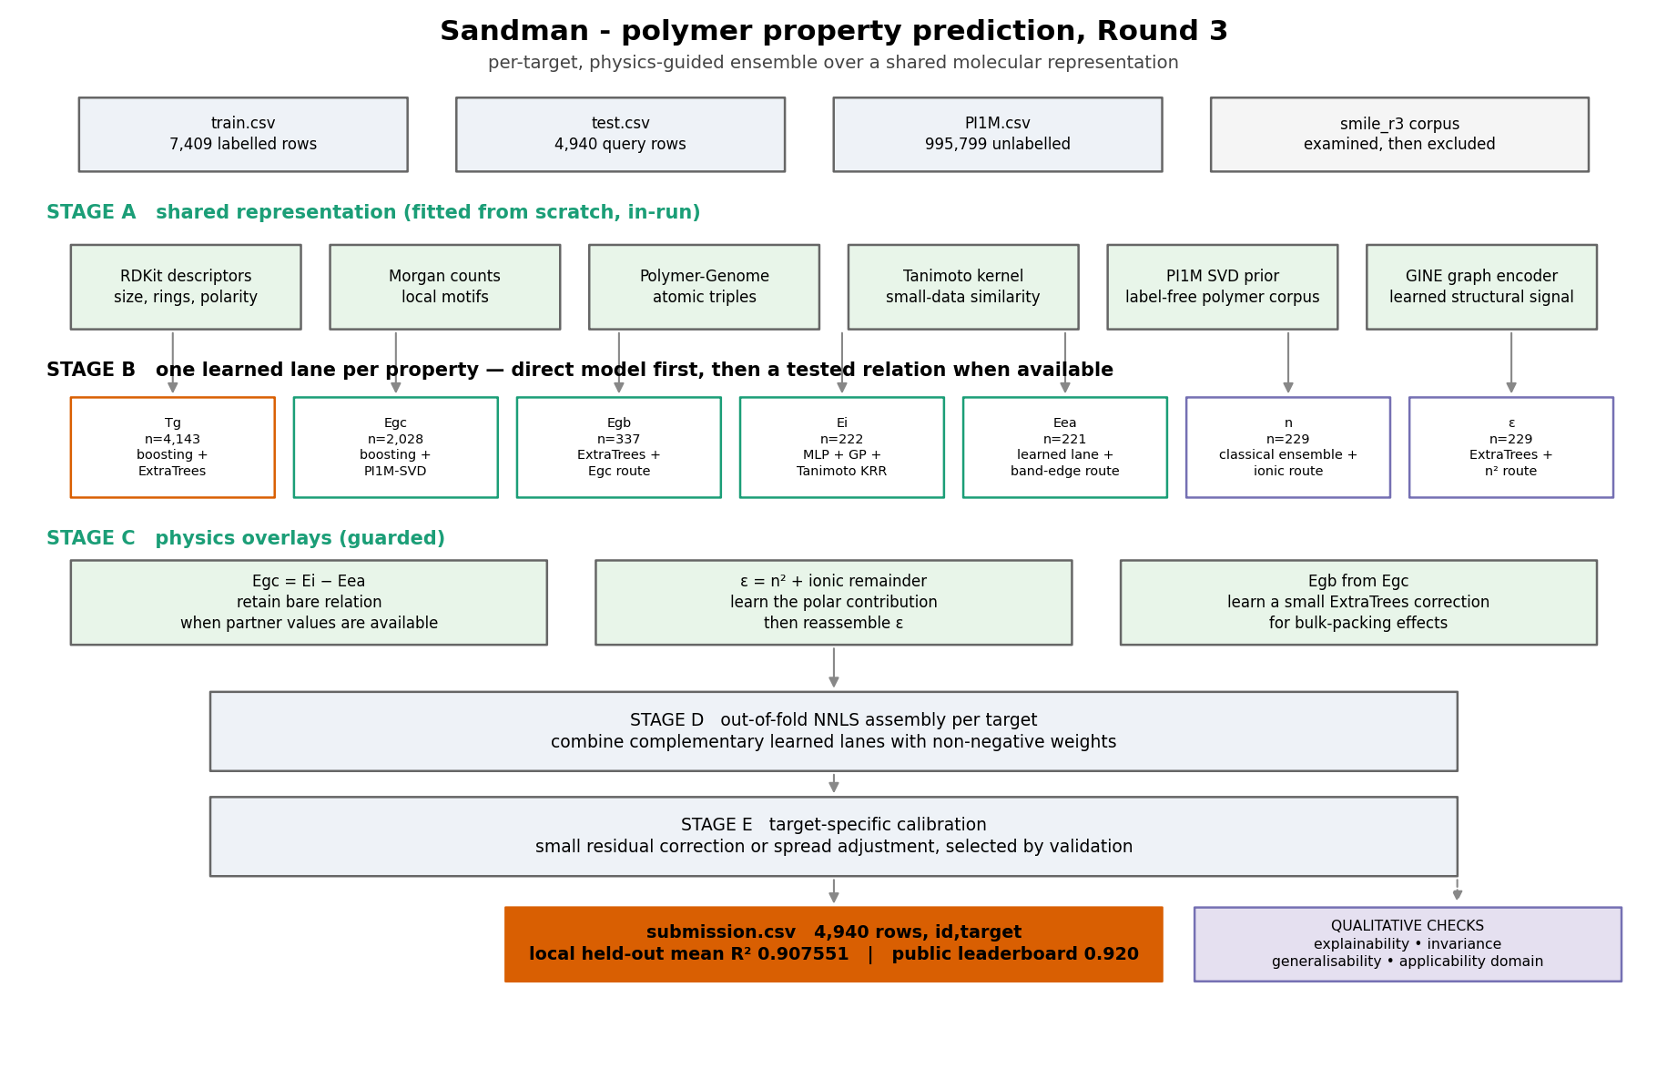
Figure 1. Pipeline architecture. Each target has a direct learned prediction lane. The physical routes are additional, guarded inputs.
Stages (In Order) | What we use | Why it matters
Shared representation | RDKit descriptors, Morgan fingerprints, Polymer Genome atomic triples, a label-free PI1M SVD prior, similarity kernels and a compact GINE graph signal | captures size, rigidity, polarity, local chemistry, polymer environments and graph structure [2–5]
Direct learned lanes | boosting/ExtraTrees for larger targets; kernel, Gaussian-process and MLP lanes for scarce targets | every property can be predicted directly from its structure, including Egc, Egb, Ei, Eea, n and ε
Guarded chemistry routes | Egc from Ei−Eea; Egb from Egc; ε from n² plus a polar remainder | adds useful information only when the companion measurement is available in the contest data protocol
Assembly | out-of-fold NNLS blend and small target-specific calibration | combines models that make different errors without giving any one lane unchecked control

Every property retains a direct learned lane: Egc uses boosting plus PI1M-SVD; Egb uses ExtraTrees; Ei combines MLP, Gaussian-process and Tanimoto-kernel learners; Eea has a learned small-data lane; and n and ε use classical ensembles. The GINE graph encoder adds a learned structural signal. Physical relations are extra routes; the direct lane remains available.

Featurization Choices
The feature set is deliberately complementary: (1) RDKit descriptors summarise size, ring content, polarity and flexibility; (2) Morgan fingerprints capture local functional groups; and (3) Polymer Genome atomic triples describe polymer-specific local environments [2,4,5].
Removing RDKit descriptors reduced grouped-CV proxy performance for Egb from 0.856 to 0.830 and for Ei from 0.794 to 0.756. Removing Morgan counts reduced n from 0.787 to 0.767. Atomic triples improved targeted Egb from 0.917 to 0.926 and n from 0.844 to 0.852.
The physics routes are also tested. The Egc = Ei−Eea relationship is already very accurate on the co-measured subset, so we keep the simple relation and reject a more flexible correction that performed poorly in leave-one-out testing. For Egb, a learned ExtraTrees correction improved the Egc-based route, so it was retained. For ε, we predict the polar/ionic contribution in ε = n² + ionic and then reconstruct ε. We also tested published gap–refractive-index relations; they did not help this dataset, so they were not used [6].

Qualitative Validation : Invariance, Explainability, Generalizability, Robustness
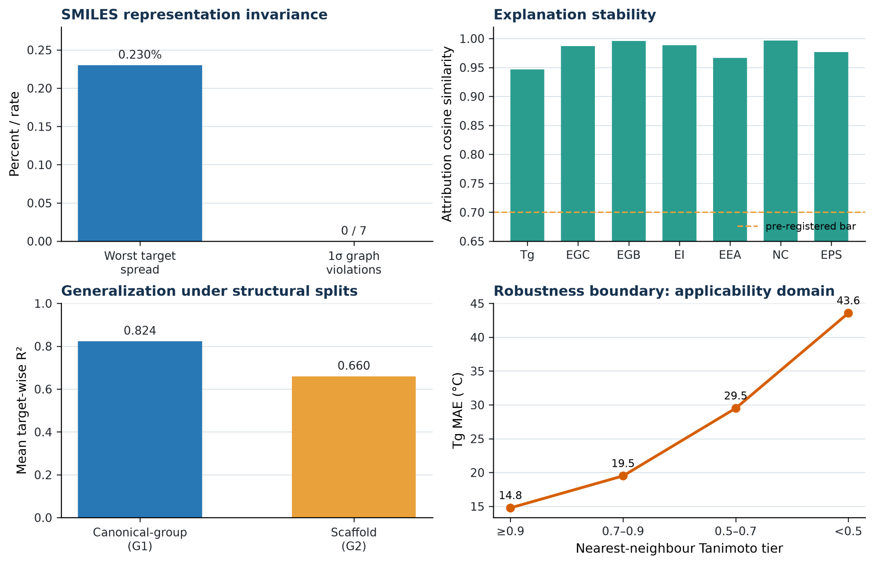
Figure 2. Qualitative evidence. Alternative valid SMILES test invariance and explanation stability; lower panels show structural-split performance and distance-related Tg error.
1. Invariance. A SMILES string is one way to write a polymer, not the polymer itself. We generated valid alternative spellings of the same repeat-unit graph. The graph-based path had zero 1σ prediction violations across all seven targets; its largest spread was 0.230% of the target training scale. The explanation similarity was 0.947–0.996 (mean 0.980). This supports the use of graph and canonical features as the main representation [8]. Remaining tasks include addition of primitive-repeat normalization so equivalent monomer, dimer and trimer PSMILES forms map to the same graph before featurization (For Ogliomers and Dimers).
2. Explainability. TreeSHAP identifies which features matter most to a prediction [9]. We tested this with a feature-removal check: removing the top 10% SHAP-ranked features from the Tg proxy lowered R² by 0.851, versus 0.043 for a same-size random removal. The reported explanations therefore identify features the model genuinely relies on [10].
3. Generalisability and Representational Robustness. The mean score is 0.824 when identical canonical structures are kept together and 0.660 when entire scaffolds are held out; all seven targets remain positive in both tests. Tg error also rises as nearest-neighbour similarity falls, so the demo shows an applicability tier and nearest analogue rather than treating every prediction equally [11,12].

2. Preliminary Salient Results

EDA Findings that Impacted our Pipeline
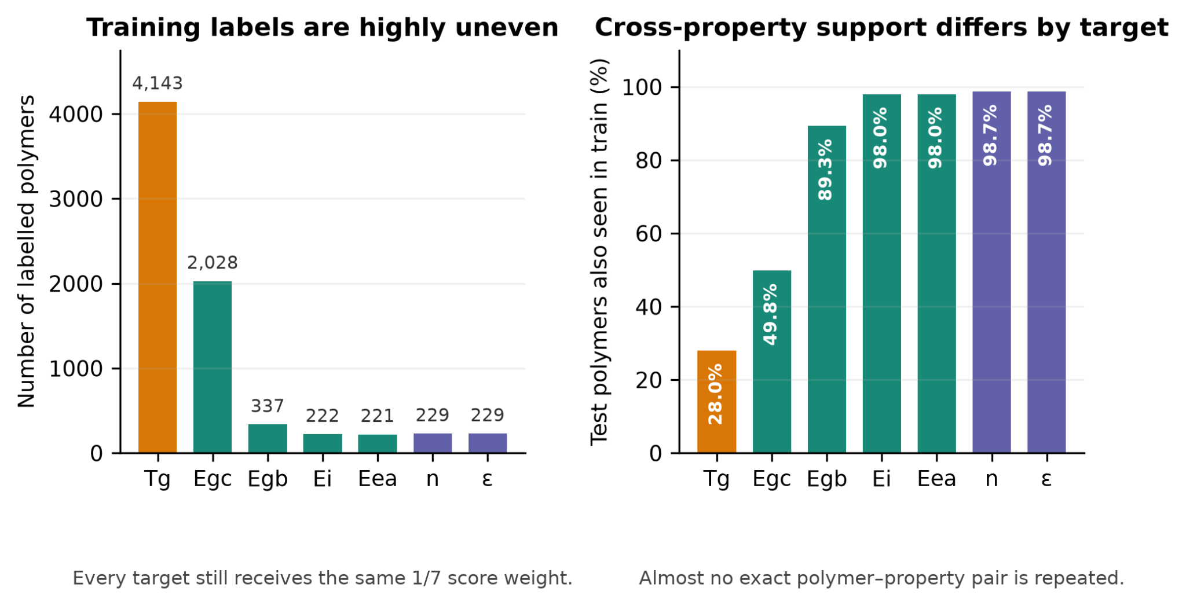
Figure 3. EDA: label imbalance and overlap with the training data. The left panel shows the uneven 7,409-label dataset despite equal target weights. The right panel shows that almost no exact polymer–property pairs repeat, while 88–99% of the small DFT targets have cross-property support. This motivates the target-specific lanes and guarded routes.
Tg contributes 55.9% of rows and 99.986% of pooled variance, but receives the same one-seventh score weight as Ei, which contributes 3.0% of rows. A single pooled loss would therefore learn mainly Tg. Train and test share 1,063 canonical structures, so we use canonical-SMILES GroupKFold; the same polymer family cannot appear on both sides of an internal split. This is why we went with our pipeline as well (Split into different prediction methods for different polymer properties)

3. Technical Challenges and Pivots
Two challenges shaped the pipeline: unequal target data and deciding when chemistry should guide a model. We use canonical-SMILES GroupKFold, target-specific learned lanes and shared molecular/polymer features. Egc = Ei−Eea is retained without a learned correction because it added noise; the Egb ExtraTrees correction is retained because it improved validation. The current roadblock is reliable uncertainty for scarce targets; until calibration is verified, we use structural-similarity applicability tiers.

4. Final Sprint Roadmap
We will finalise the pipeline, evidence tables and dashboard, including a same-polymer SMILES invariance demonstration. We are testing a pure-ML alternative (current grouped-CV mean R² 0.816344), grouping explanations into chemical concepts, and assessing a small literature-based polymer panel. For electronic candidates, explanations highlight conjugation, aromaticity and band-edge motifs; for optical candidates, they separate refractive-index and polar/ionic contributions. The final deliverable is a trained prediction pipeline with an interactive dashboard for structure, prediction, explanation and applicability.
References
1. Kuenneth, C. et al. Polymer informatics with multi-task learning. Patterns (2021).https://doi.org/10.1016/j.patter.2021.100238
2. Kim, C. et al. Polymer Genome: a data-powered polymer informatics platform. Journal of Physical Chemistry C(2018). https://doi.org/10.1021/acs.jpcc.8b02913
3. Ma, R. & Luo, Y. PI1M: a benchmark database for polymer informatics. Journal of Chemical Information and Modeling (2020). https://doi.org/10.1021/acs.jcim.0c00726
4. Landrum, G. RDKit: Open-source cheminformatics. https://www.rdkit.org
5. Rogers, D. & Hahn, M. Extended-connectivity fingerprints. Journal of Chemical Information and Modeling(2010). https://doi.org/10.1021/ci100050t
6. Moss, T. S. Relation between the refractive index and the energy gap of semiconductors. physica status solidi (b)(1985). https://doi.org/10.1002/pssb.2221310202
7. Ravindra, N. M. & Srivastava, V. K. Variation of refractive index with energy gap in semiconductors. Infrared Physics19(5), 603–604 (1979). https://doi.org/10.1016/0020-0891(79)90081-2
8. Bjerrum, E. J. SMILES enumeration as data augmentation for neural network modelling of molecules (2017). https://arxiv.org/abs/1703.07076
9. Lundberg et al., From local explanations to global understanding with explainable AI for trees, Nature Machine Intelligence, 2020, DOI 10.1038/s42256-019-0138-9.
10. Hooker, S. et al. A benchmark for interpretability methods in deep neural networks. NeurIPS (2019). https://arxiv.org/abs/1806.10758
11. Bemis, G. W. & Murcko, M. A. The properties of known drugs. 1. Molecular frameworks. Journal of Medicinal Chemistry (1996). https://doi.org/10.1021/jm9602928
12. OECD. Guidance Document on the Validation of (Q)SAR Models (2007). https://www.oecd.org/env/guidance-document-on-the-validation-of-quantitative-structure-activity-relationship-q-sar-models-9789264085442-en.htm

Appendix A — experiment register
Experiment family | Representative scored result | Decision
D1: physical routes | ε +0.0666; n +0.0434; Egb route 0.9205 → 0.9478 | retain the three supported routes
D2: representations | atomic triples: Egb 0.9167 → 0.9259; n 0.8438 → 0.8519 | retain polymer-specific triples
D3: label-free corpora | PI1M SVD helped; all-target corpus SVD hurt | retain the polymer-only prior
D5: classical ML and kernels | NNLS blend +0.02 to +0.05 over the best member | match model family to target size
D6: cross-property learning | partner labels helped all five small DFT targets | use availability-guarded routes
D8: calibration | character residual positive on five targets; isotonic calibration overfit | keep only validation-supported adjustment

